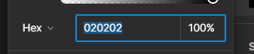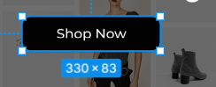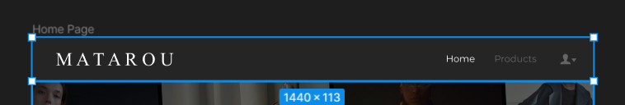

**Link Figma :**

[**https://www.figma.com/file/uF9shQO9SJUV7LGbQhf6JJ/Software-Development-Project-Mock-Up?node-id=7%3A154&t=htZnAwWWAmow9umG-1**](https://www.figma.com/file/uF9shQO9SJUV7LGbQhf6JJ/Software-Development-Project-Mock-Up?node-id=7%3A154&t=htZnAwWWAmow9umG-1)